**A/P INVOICES PAID VIA ACH**

1. In the vendor file, check the toggle box marked (Credit Card/ACH). If this toggle box is checked, then when selecting vendor invoices for payment through Payment Selection by due date (VB1) these vendors can be excluded from the run. This will allow those vendor invoices to be paid on a separate run.

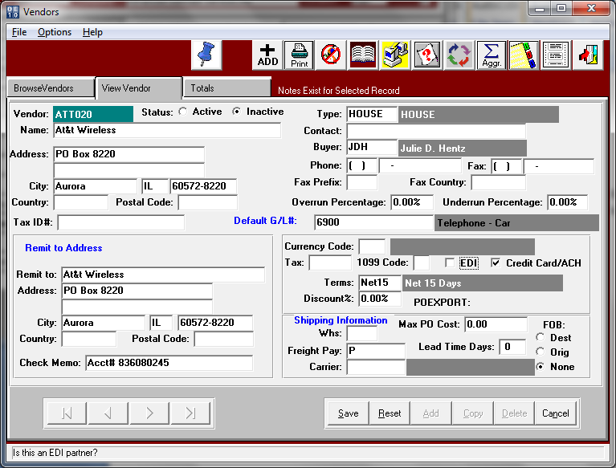

2. On the Select by Due Date screen there is a toggle box called [Credit Card/ACH Vendors Only].

Use this process if you wish to use checks to pay invoices instead of creating credit memos.

When credit card/ACH toggle box in vendor file is checked, then the payment selection by due date screen (VB1) will search all vendors with available invoices due within the terms. If that vendor has the Credit Card/ACH toggle box checked, then only those vendors will be included on the selection run.

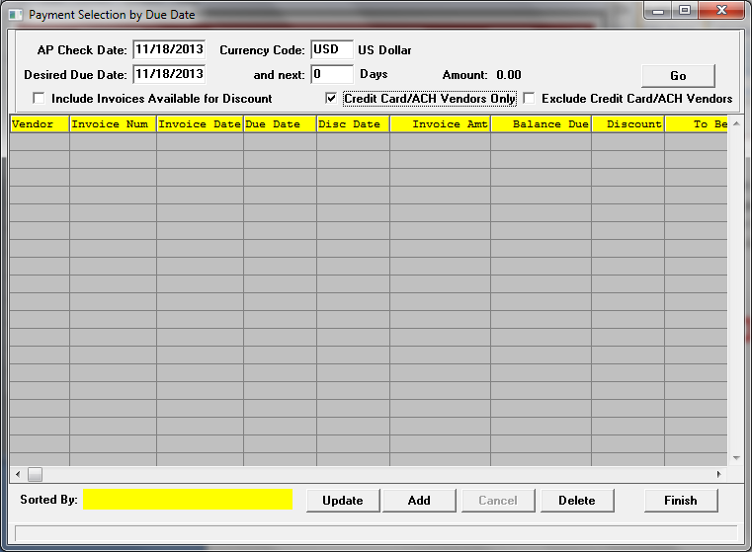

**STEPS TO PROCESS PAYMENT FOR ACH PAID INVOICE**

1. Enter A/P Invoice in (VU1) - (being paid via ACH) –

Debit - correct Expense account for invoice

2. To delete Vendor Invoices paid via ACH from AP Aging.

**a. Create an AP credit memo via VW1**. (Use if you do not wish to create checks via process (b) below. For those vendor invoices that were paid by ACH, enter an accounts payable credit memo to take that invoice off the aging. On the line item of the memo, instead of crediting the expense account, override that account number with the CASH account number. This will take the cash out of your cash account number.

Credit – CASH account number

**OR**

**b. Create an AP Check via VC1**. First select the invoice for payment (VB1or VB2) and then on the print checks screen (VC1), check the toggle box that says [ACH]. This will default the check starting at 8000000 range. This will be your starting check number for just ACH payments. The bank file will then store the new starting ACH check number as well as your normal check run range. Print the checks to plain paper or screen. You can then scan and email a copy to your vendor. If your check is formatted in Xprint format, you can print your check to the screen and then email a copy directly from Xprint.

Credit – CASH account number

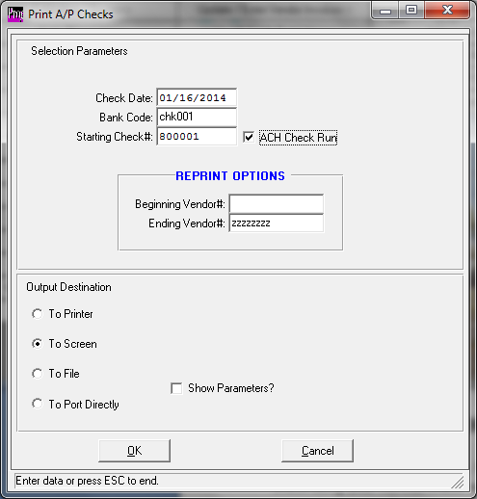

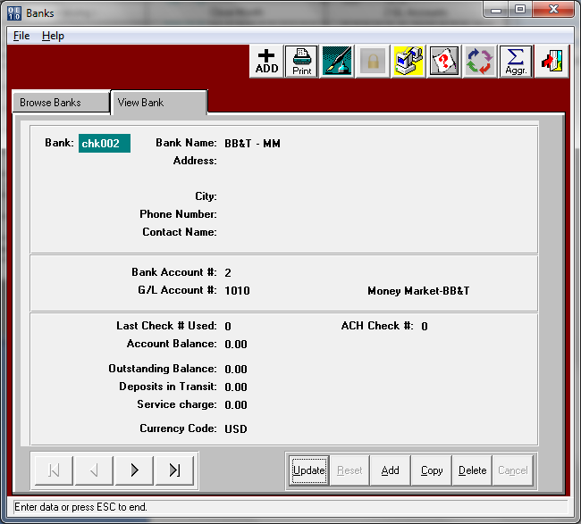

*New ACH check number range added to each bank file to store new ACH check number range. Check range must be 8000000 - 999999*

Example:

Account # Description Debit Credit

1000- Cash (2)Invoice Payment ($1,000.00)

2100 - Accounts Payable

(1)Vendor Utility Bill ($1,000.00)

(2)Payment/CM Vendor Utility Bill $1,000.00

6800- Utilities

(1)Vendor Utility Bill $1,000.00